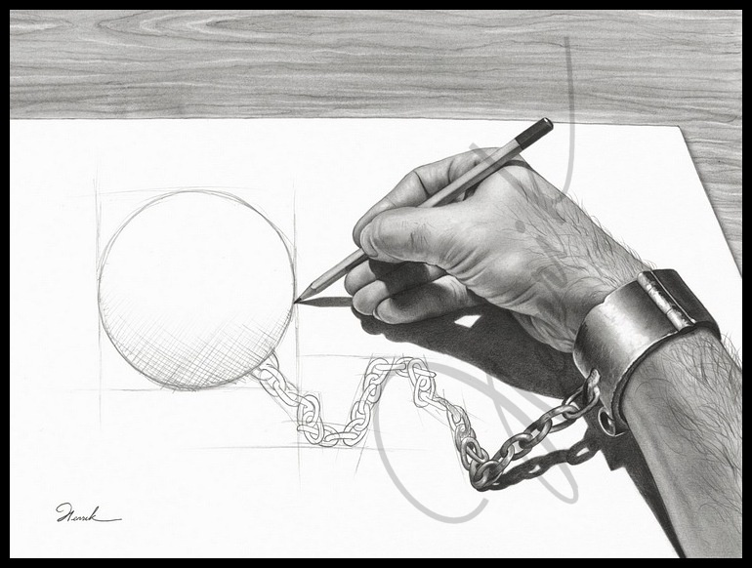

<http://www.deviantart.com/art/Prisoner-of-my-own-33234157>

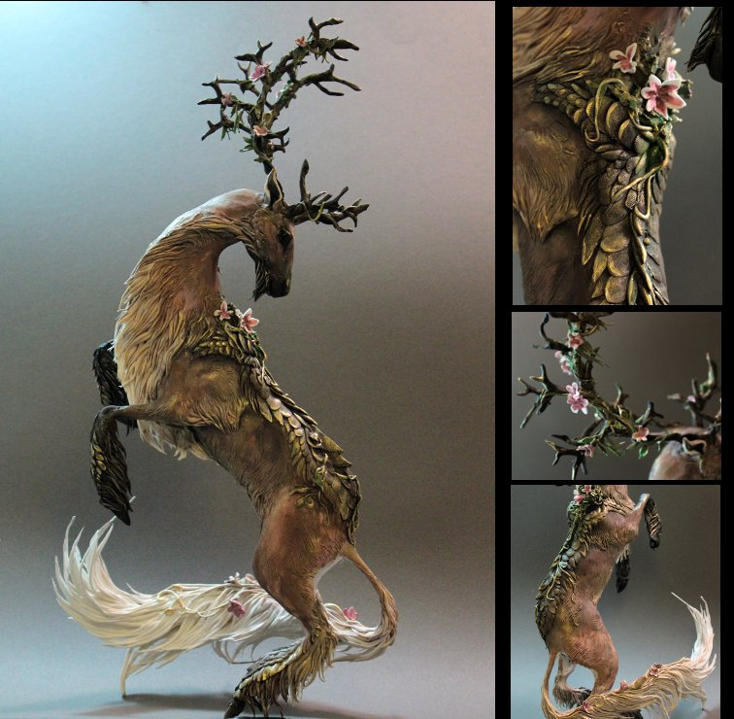

<http://www.deviantart.com/art/custom-order-Kirin-302856333>

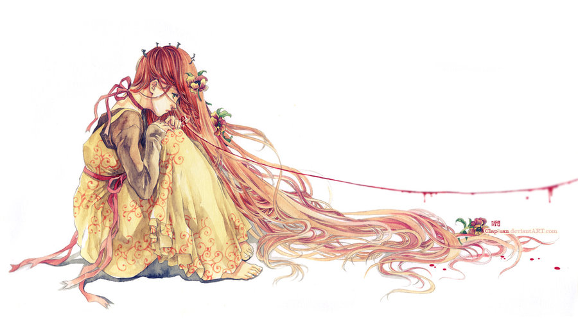

<http://www.deviantart.com/art/Waiting-196910840>

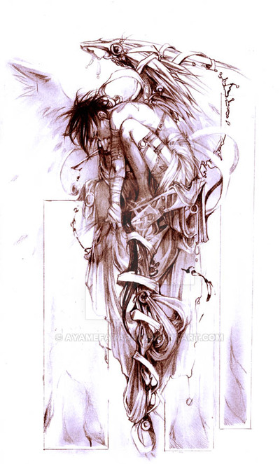http://www.deviantart.com/art/Memories-of-a-Martyr-6528257

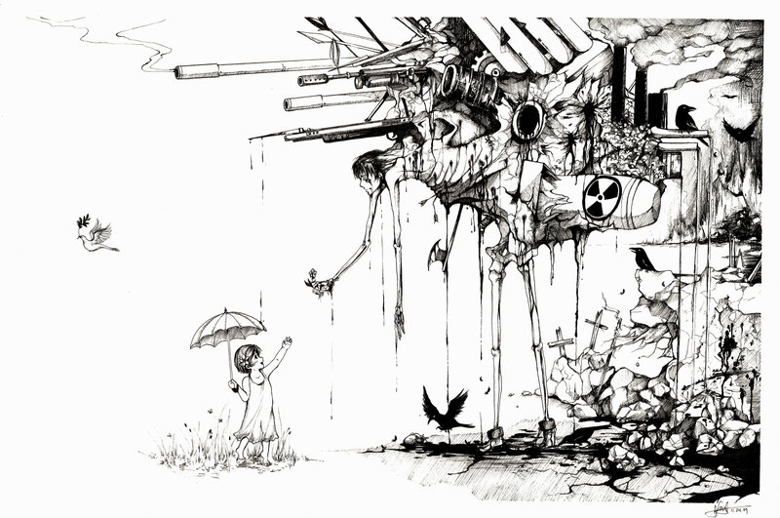

<http://www.deviantart.com/art/War-and-Peace-164161704>

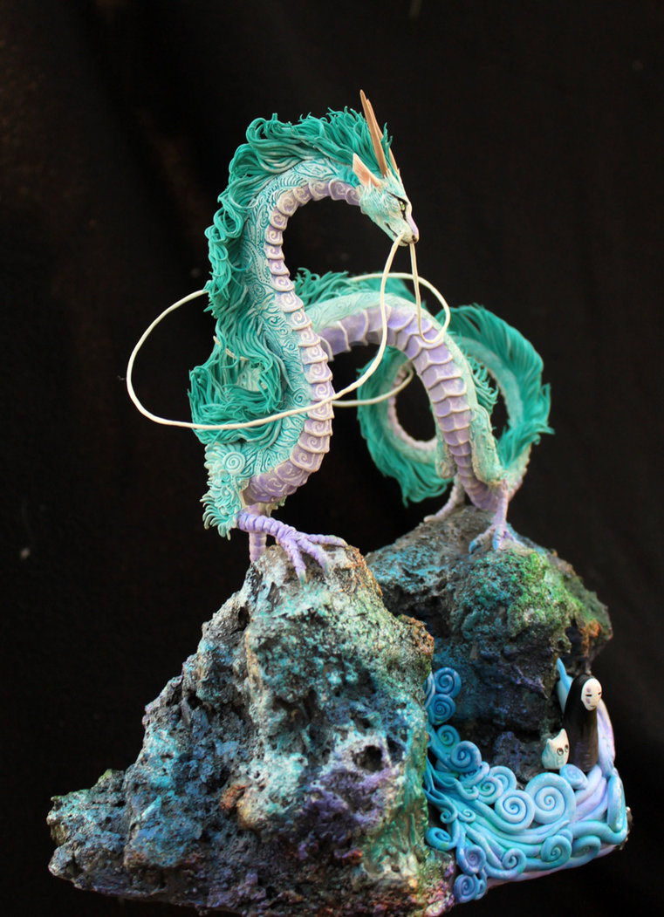

<http://www.deviantart.com/art/Haku-Dragon-380100718>

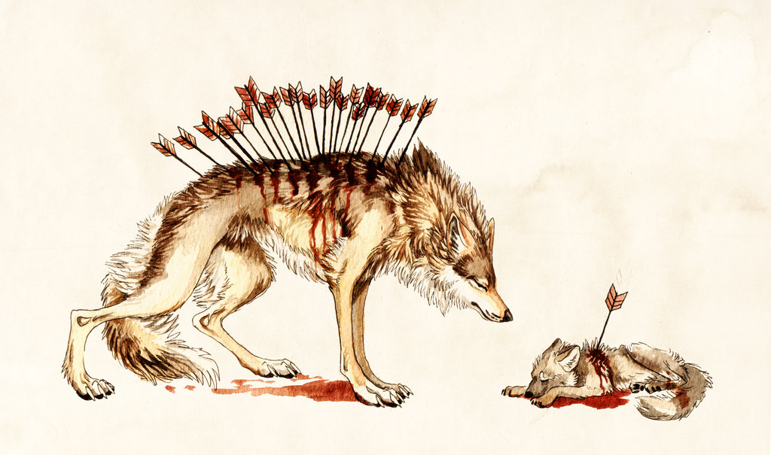

<http://www.deviantart.com/art/Loss-468754170>

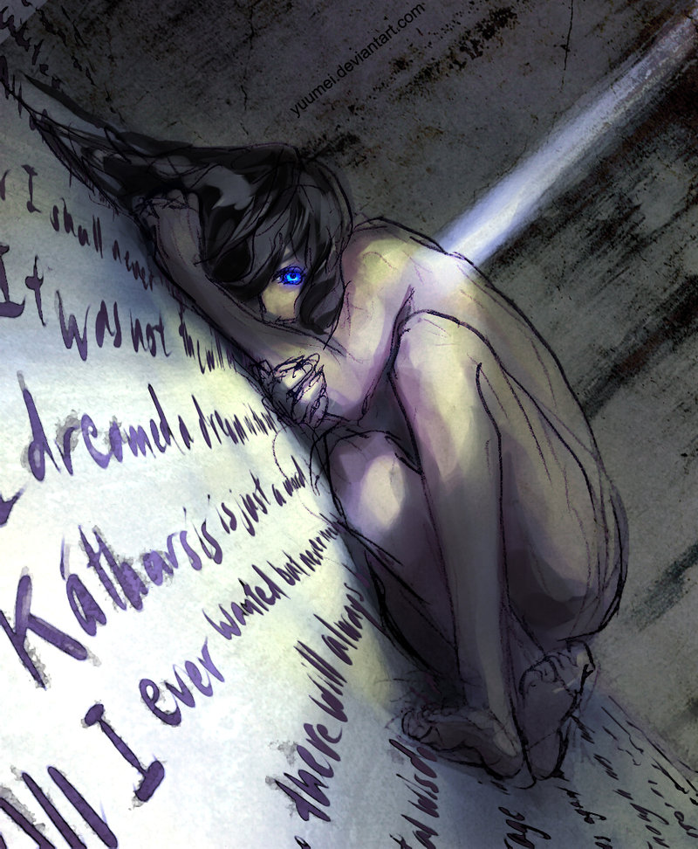

<http://www.deviantart.com/art/Cold-293303062>

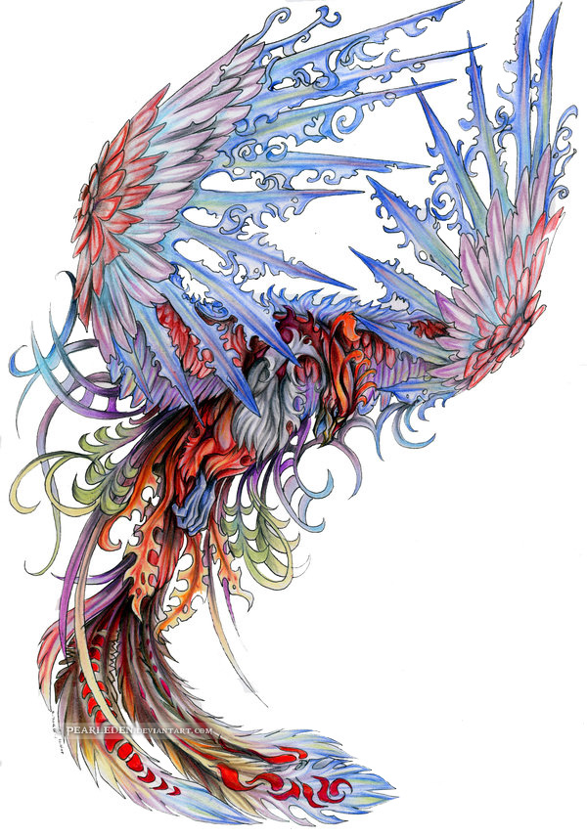

<http://www.deviantart.com/art/Phoenix-139538752>

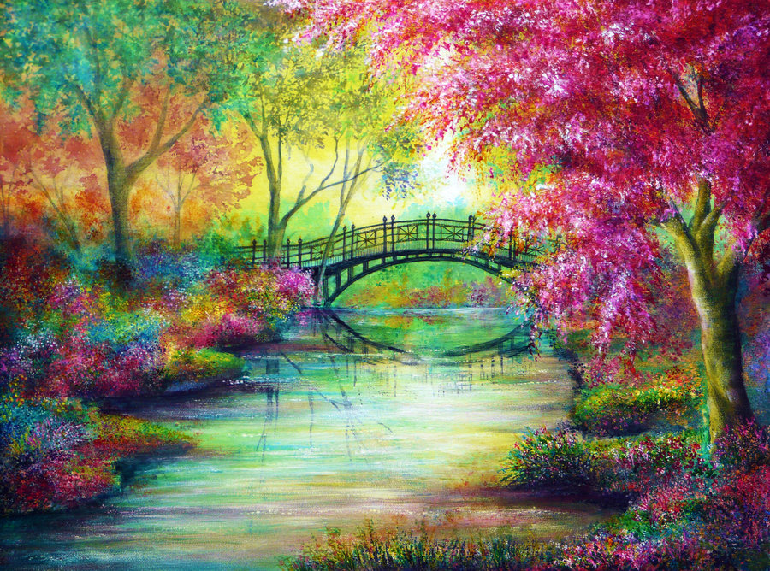

<http://www.deviantart.com/art/Dreams-of-Elysium-323312673>